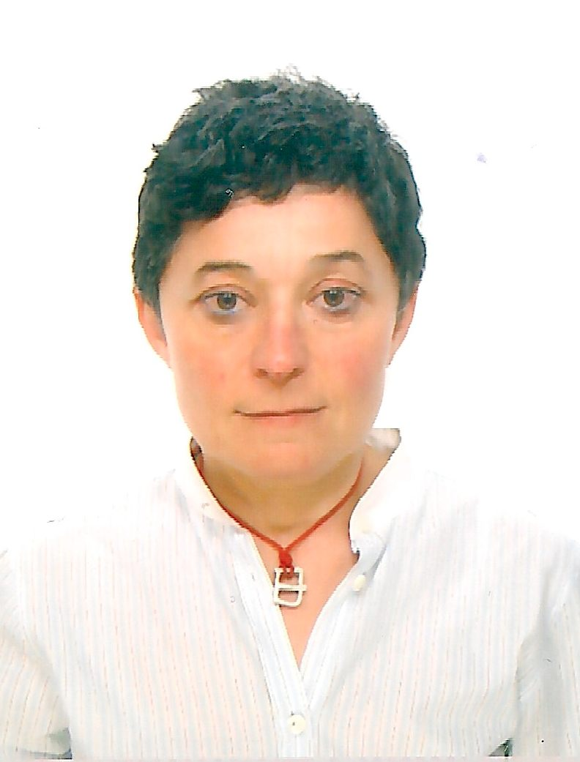
First / Last Name MAGALÍ MARTÍNEZ SOLIMÁN
Phone / e-mail +34 678 788 343 / magali@nogaps.es
Linkedin http://es.linkedin.com/in/magalimartinezsoliman
Born Madrid, 13 September 1963
PROFILE
Combining an engineer’s background, languages as a key factor for communication, and a deep social and human engagement, in my work as a consultant, facilitator and trainer, I focus on citizen leadership, gender, empowerment, and sustainable development, integrating leadership perspective and culture at all levels, to reduce the gaps between our realities and our dreams, hopes, and/or needs.
Curious, enterprising, creative, with a passion for conversations and for people’s growth, and fascinated by the power of relationship systems, the “co-active® way” wholly defines what I am hungry to be and to do in the world. In the last 4 years, as a co-active® coach and leader, I have become much more efficient in my action to transform the paradigm of human relationships and to contribute to a happier society.
CURRENT OCCUPATION

(2005 →) CONSULTANCY AND TRAINING
- Entrepreneur: Co-Founder and Head of Development, TRAVESÍAS POR LA IGUALDAD, consulting company (founded 2005) focused on employment, gender, and rural/local development. My topics: citizen leadership, employment, empowerment, adaptability, W&LB, time management, gender budgeting, entrepreneurship. Author of manuals and projects & programs designer on these topics.
Main clients: Spanish regional governments (Navarre, Basque Country, Murcia, Extremadura) and local authorities (over 50 councils) and their federations, private companies and their associations, local development groups, Universities, trade unions, foundations, communities and social organizations.
- Outplacement consultant: lukkap – formerly DBM Spain (2010-2012), focused on outplacement, career transitions and self-employment-entrepreneurship (86% success rate in 2010, 84% in 2011).

(2008 →) COACHING
Certified Professional Co-Active Coach (CPCC): 900 hours of practice, coaching individuals and groups/systems, mainly around job & career transitions, leadership, communication, business partnership, and personal growth. Team Diagnostic AssessmentTM (TDA) facilitator. PCC application, 5 June 2012.
- Individual coaching. Private clients (±360 hours); executive & professional coaching (±440 hours) for public and private organizations. Main clients: Augere (third party clients, Telefónica, 200 hours); INAI, Government of Navarre (100 hours); Riu Valls Association (80 hours); lukkap-DBM (40 hours).
- Team coaching and large group processes (±100 hours): Emakunde, Basque regional government, Women’s Associations programme (30 hours); PLxC program, Navarre and Asturias (30 hours). Regional government of Extremadura, IMEX, Cáceres (2010, 100 participants, 6 hours).

(1980 →) TRANSLATION AND INTERPRETATION
- Translator: over 60 books published. Specialised in art (Thyssen-Bornemisza Museum, Guggenheim Bilbao, MBA Bilbao, Picasso Museum), children’s literature, film, feminism, history, politics, and society. Translator into Spanish of the Co-Active Coaching book, eds. 2 and 3, (Coaching Co-Activo, Lid EE, Madrid, 2009/2012) and of CTI’s core curriculum and CPCC program materials for Augere.
- Interpreter (simultaneous and consecutive): over 800 hours, of which over 200 for Augere’s CRR-ORSC courses (relationship & systems coaching) (Madrid & Barcelona, 2010-2012).
PREVIOUS EMPLOYMENT HISTORY

(2000-2005) TECHNICAL ASSISTANCE – EUROPEAN PROJECTS
- Financial and operations manager, head of transnationality, ESF-Equal project “Cireres per la Igualtat” (2006-2008, 1,5M€). Gender expert and head of transnationality, ESF-Equal project AGMetal (2006-2008, 1,3M€). A3 manager (practices transfer and dissemination), ESF-Equal project “IOMetal”, Metal- Sector Organizations Federation of the Valencian Community, Spain (2003-2004, 1,7M€).
- Technical expert for the Equal ESF Community Initiative of the European Union, ESF Spanish Administrative Unit (UAFSE), Labour and Social Affairs Ministry (MTAS) (Madrid, 2001–2003).
- Personal assistant to the President of the Assembly of the Western European Union (WEU). Congreso de los Diputados (Spanish Parliament) (Madrid, January 1997- January 2000).

(1991-2001) ENGINEERING

- Image Analyst, AURENSA-Teledetección, updating of CORINE LAND-COVER (Madrid, 2001).
- Quality Assurance & Environmental Management Assistant, Plomífera Castellana S.L. (Madrid, 1996-1999).
- Data Manager - Programmes Unity, Health Department, Spanish Ministry of Health (INSALUD - Fondo de Investigación Sanitaria) (Madrid, May 1991 - June 1995).
EDUCATION, TRAINING, COMPUTING, LANGUAGES

ACADEMIC EDUCATION
Agronomist & Engineer. Main subject: Agrarian Economy. Escuela Técnica Superior de Ingenieros Agrónomos. Universidad Politécnica, Madrid, 1995.
Equal Opportunities Agent. Master’s degree, Universidad de Valencia (400 hours), 2004.
Expert in Geograhic Information Systems, Remote-Sensing and Cartography, Universidad de Alcalá de Henares (360 hours), 2000, and Universidad Complutense de Madrid (265 hours), 2000.
Master’s degree in Environmental Management. Instituto de Investigaciones Ecológicas/The Open International University, Madrid (420 hours), 1994.

COACHING AND LEADERSHIP TRAINING
Professional Coaching: Co-Active Coaching Training Program, Augere & The Coaches Training Institute (CTI), 2007-2008. CPCC Certification Program, CTI, 2012.
Systems Coaching: Organization & Relationship Systems Coaching Training (ORSC), Augere & Center for Right Relationship (CRR), 2008-2009.
Team Coaching & Team DiagnosticTMTraining, Team Coaching International (TCI), Team Diagnostic AssessmentTM (TDA) facilitation, 2009. Renewal 2012.
Leadership: Co-Active Leadership program, The Coaches Training Institute (CTI), as a participant in 2008 (Sitges, Spain), 200 hours, 106,75 certified hours; as an assistant in 2009-2010 (North Carolina, USA) and in 2011-2012 (Sitges, Spain), 1st program in Spanish.
Co-Facilitation Training: Alchemy³, CRR-Global, 2010 (Istanbul, Turkey), 30 hours.
Coaching with horses: “The Red Horse Academy”, Gentle Leadership (Aberdeen, UK), 2008, 30 hours.

COMPUTING
Advanced user: Windows, Mac, MS-Office, Acrobat, Internet/Intranets, Visual Basic, databases, engineering software (Autocad, QSE), SIG and Remote-Sensing (Arc-Info, Arc-View, Idrisi, Cartalinx, Erdas, PCI).

LANGUAGES

Spanish / French | Mother tongues (bilingual). Usual working languages (spoken and written). Direct and reverse translation.  Spanish Baccalaureate (Sciences) and French Baccalaureate (C Series, Mathematics and Physics). Lycée Français, Vienna, Brussels and Madrid.
English | Proficient user. Usual working language (spoken and written). Direct and reverse translation.
German / Italian  Portuguese-Galician, Catalan  Serb | Independent user. Working languages (spoken). Direct translation.  Independent user (conversation, reading). Working language (spoken).  Basic user (conversation, reading).

